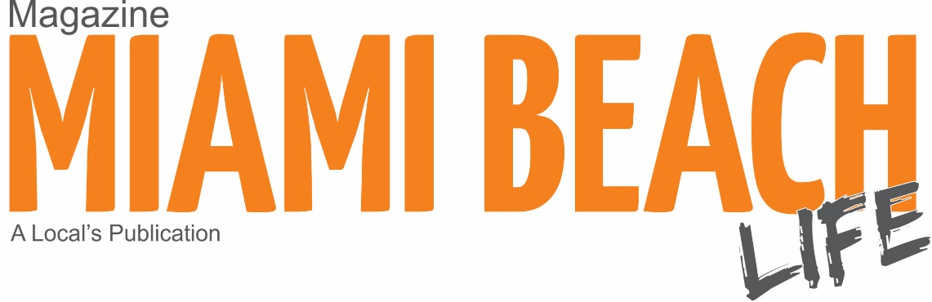
Commercial Distribution

South Beach/Mid Beach
33139/33140 Residential: 38% of the total households
-Art Deco Center 10th St & Ocean Drive
-Master pizza 17th street Alton Rd.
-FlyWheel 19st Purdy Ave.
-Green Monkey 18st Bay Road.
-Title boxing 18st
-Miami Beach Clinic Center 8th St.
-Vespa 17st
-Sobe nail 17st
-Blush Nails 16st Alton Rd.
-Starbucks 16th st
-Starbucks 9th st.
-Universal Music Group 4st Washington Ave.
-Carma PR 4st Washington Ave.
-Einstein bagels 15st
-Epicure Market 16th st.
-Panera 14st
-Panther Coffee 18st
-Nugbrant 13st
-Tastee 9th st
-Gustavo briand studio 18st
-Sultry eyes lash studio 18st
-Japanito 18st Purdy Ave.
-Starbucks 200 Ocean Drive
-First Surf Shop 100 Ocean Drive
-Starbucks 12st Washington
-Chase Bank 17st. & Alton Rd.
-Bank of America Lincoln Rd.
-Bank of America 41st & Sheridan
-Miami Beach Chiropractor 9st & West Ave.
-Sheen wellness 45st Biscayne Blvd.
-Bauman cosmetic group 45st Biscayne Blvd.
-Mount Sinai Hospital (various offices)
-Miami Beach Animal Hospital 17st. Alton Road
-Mangos Tropical Café 8th st. Ocean Drive.
-Clevelander 10st & Ocean Drive.
-Whizzy scooters 7th st. & Collins Ave.
-WeWork 5th St & Lincoln Road
-Buro Miami 1815 Purdy Ave.
-South Beach Tanning 8th St & Alton Rd.
-Prestige Image Barbershop 1322 Alton Rd.
-iNail Spa 1326 Alton Rd.
-Douglas Elliman Real Estate 1111 Lincoln Rd.
-White Light Skin Care 110 Washington Ave.
-Miami Wellness Center 1523 Alton Rd.
-For Eyes 1519 Alton Rd.
-Miami Beach Chamber 1920 Meridian Ave.
-Orange Theory Fitness 5th Street & Alton Rd.
-Hair Cuttery 15th Street & Alton Rd.
-European Wax Center 9th Street & West Ave.
-Pinecrest Bakery 15th Street & Alton Rd.
-EM Nail Salon 9th Street & Alton Rd.

- Hotels: Astor Hotel, Avalon Hotel, Beacon Hotel, Catalina hotels, Raleigh hotel, Shelborne hotel, Westgate hotel, Abbey, Betsy hotel, National hotel, Delano Hotel, Clinton Hotel, Sagamore Hotel, President Hotel, The Hotel, Waldorf Hotel, Julian Hotel, Jazz Hotel, Best Western, Marriott, Seagul Hotel, St.Augustine hotel, Freehand hotel, Days Inn, Four Points Sheraton, Palms Hotel, Red Sobe Hotel.

North beach
33141 Residential: 55% of the total households.
-Bandshell 74th st & Collins Ave.
-Immigration center 79st
-Urban resource 79st
-Normandy Maret 71st. & Collins Ave
-Estrella Insurance 71st & Collins Ave
-Subway 71st & Collins Ave
-Georges Restaurant 71st. Harding Ave.
-Hebrew Market 74st & Collins Ave
-Buenos Aires Bakery 71st & Collins Ave
-City National Bank 71st. Harding Ave
-Miami Beach Dental 71st. Harding Ave.
-Manuel Fernandez accounting 201 71st
-Cachito bakery 71st & Harding Ave
-Manolos Restaurant 74st & Collins Ave
-Aromi Restaurant 74st & Ocean Terrace
-jb bikes 74st & Collins Ave
-Gaffas optical 74st & Collins Ave
-Moises bakery 73st & Collins Ave
-Bank of America 74st & Collins Ave
-Chase Bank 69st & Collins Ave
-Gol Restaurant 71st
- Hotels: Carillon hotel, Deauville Hotel 68st, Days Inn 74st, New Hotel 73st, Best Western 71st

